BAMBOO CRAFT SMALL BUSINESS EMPOWERMENT IN KERTAWANGI VILLAGE, CISARUA DISTRICT, WEST BANDUNG DISTRICT

Siti Patimah¹, Erti Dinihayati ²
^{1,2}Faculty of Social and Political Sciences, Universitas Pasundan
Email: ¹siti.fatimah@unpas.ac.id, ²ertidinihayati@unpas.ac.id,

ABSTRACT

One of the natural resources in West Bandung Regency is bamboo. The products produced vary, mostly in the form of household appliances. The problems faced by business actors are related to marketing their products. In addition, it is also related to production, where there are many orders but are constrained by equipment, especially machines. In addition, business actors do not know how much profit or loss they experience each month because there is no bookkeeping done. The implementation method used to overcome the problems faced by business actors is through training and technical guidance. The training is carried out by giving lectures and understanding related to marketing and finance. The technical guidance carried out is by direct practice and continued by providing understanding until finally being able to be independent. In addition, the provision of machines to partners. Training activities and marketing guidance have been carried out in the form of making online marketing features on social media, namely Facebook and Instagram. As well as the provision of machines to be able to draw quickly, accurately, cheaply and neatly. In addition, training and simple financial texts have also been provided. So that partners can make simple records and can determine the determination of the cost of production.

Keywords: Craft, Empowerment, Small Business

Introduction
West Bandung Regency is one of the areas in West Java which has abundant natural resources. One of the natural resources owned is bamboo plants. Bamboo is a non-timber forest product that is well known and very close to the life of the general public because its growth surrounds people's lives. Setiawan Budi (2010). Bamboo has many benefits in the lives of people in the region, one of which can provide benefits in fulfilling their daily needs.
This of course creates jobs for the local community, because processed bamboo is one of the handicraft industries. This industry is able to absorb the largest workforce, namely 120 559 people (95.15 percent) of the 126 708 workers absorbed by the industrial sector. Mesiyani (2020). Industries produced from bamboo plants in general can be used as building materials, transportation, culinary, medicine, household appliances, musical instruments, and kites. Various products are produced, in almost several areas in West Bandung Regency most of them process bamboo into various products. Most of the products produced are in the form of household appliances.
Sundanese people call several household appliances such as boboko, hihid, sieve, nyiru and others. In Sonobekel Village, Tanjunganom District, Nganjuk Regency, kitchen utensils and cleaning equipment made from bamboo are called gedek, galar, betek, Umi Mintarti et al (2019). However, there are also those who produce products from bamboo but with a more modern quality. Even the bamboo products produced have penetrated into several regions both within and outside the country. This was experienced by a craftsman in the village of Kertawangi, Cisarua District, a craftsman who had been running his business for a long time. Initially, the craftsmen saw many bamboo plants around their house.
The idea of turning bamboo into something useful crossed his mind. Gradually efforts to turn bamboo into useful goods materialized. As time went on, craftsmen continued to transform bamboo into items that had aesthetic value. Until finally, the innovation and creativity that he did were widely known by people and even his products had penetrated into various regions and even several countries. However, the business run by craftsmen is also never separated from the problems they face.
Some of the problems they face are related to business aspects, especially business management. Based on the problems faced, the problems faced by bamboo craft partners can be identified, namely marketing that has been carried out so far has only been conventional and uses production parties, especially many orders but are not fulfilled due to limited equipment owned and related to finance, partners do not have financial records.

- Method of Implementation

Partnership Program Implementation Method In this activity in Bamboo Crafts in Kertawangi Village, Cisarua District, in practice the Team will carry out activities based on several methods. The methods implemented will be through several methods including: Training (Lectures, Discussions, Demonstrations,) and Technical Guidance (Bimteks).

Activity Procedure The following is an explanation of each science and technology method that will be applied:

Training Training or training is a method given in order to provide knowledge and certain things that are delivered by a trainer (Gendro Salim, in a complete business guide, media synergy, Jakarta. 2010). This training method is divided into three stages in three years as follows:
- Training
- Training Part 1 (One) training in the form of marketing, will be given a conventional understanding first after that an explanation will be given on online marketing.
- Training Part 3 (three): Training on finance related to simple record keeping
- Technical guidance
- Technical guidance (Bimtek)
Technical guidance (Bimtek) is an activity carried out after the training activities are carried out. This technical guidance activity is given to Bamboo Crafts partners. The purpose of this technical assistance is that partners can apply the results of the training with technical guidance and direction from trainers (supervisors). Binteks are done only for finance or simple bookkeeping. A. Participation in the Bamboo Crafts Business in Program Implementation In implementing the program in the bamboo craft business to achieve solutions (solving) business management problems related to marketing, production and finance, if the majority of partners (50%) can achieve the expected competencies, namely being able to improve the bamboo craft business so that the results obtained can increase business sales, can increase production after additional machines and can increase understanding related to bookkeeping (finance). In addition, partners have contributed to this activity where partners have taken the time to provide data.
Implementation Monitoring is an activity carried out by the activity implementing team in observing and monitoring the implementation of training, and Bintek which is carried out or carried out by instructors or assistants, while the evaluation implementation is an assessment activity carried out by the implementing team after the training program and Bintek and business management relating to marketing, production and finance in the bamboo craft business. Evaluation and monitoring is carried out to see the results of the implementation of activities. The results of this activity will be a reference for related parties to continue to provide benefits for both partners and certain parties such as the local government and the West Bandung Regency government in particular.

- RESULTS AND DISCUSSION
The community service activities carried out for bamboo handicraft craftsmen began with a survey conducted by the Team. Where the Team coordinated with business actors, in this case the Bamboo Craftsmen with the owner named Mr. Dian Setiawan, whose address is Kp. Cisarua RT.01 RW.12 Kertawangi Village, Cisarua District, West Bandung Regency. Based on the results of coordination with partners, information was obtained that business actors experienced a decline in sales during the Pandemic. Previously partners always ran a business with sales that were always stable.
However, since the pandemic took place, partners have not been able to run their business. In fact, the partners almost went out of business, because the production could not be sold, even marketing was closed. Efforts are always made by the business owner until in the end the business partners offer to run the business together. From that moment on, the business started to run again by running a collaborative business. Pa Dian runs a business together with Pa Adang who are both in the business of handicrafts in the field of bamboo.
On March 15 2022, the team started to carry out activities to assist Pa Dian in running his business. The activity carried out was to provide explanations to partners regarding business management, which began with online marketing delivered by Mrs. Erti Dinihayati, S.Sc., M.Stat, then production by providing production equipment in the form of laser machines carried out by the team assisted by students namely Fernanda Putri Tumundo and Suheri. Followed by providing training and assistance regarding simple bookkeeping delivered by Dr. Siti Patimah, SE., M.Sc. It is hoped that by carrying out empowerment activities for partners, it can revive and businesses can run again as before the pandemic occurred.

Marketing Activities
a. Training
In marketing activities, the team first conducts training for partners, where partners are given an explanation of conventional marketing, after that the business actor or in this case the partner is given an explanation of how online marketing is carried out. After the team gave an explanation to partners, and discussed the opportunity for partners to convey related to the marketing that has been carried out. Based on the explanation submitted by partners or business actors that so far partners have received guidance from the government regarding online marketing, but in practice partners do not carry it out alone because of difficulties.
Therefore partners are assisted by other business partners in carrying out online marketing. However, to complement and provide explanations to partners, in this marketing partners are assisted by a team and given explanations to complement the marketing they carry out. The team also advises partners to carry out marketing independently that does not depend on other partners. This is done to understand clearly and be able to have their own market in running their business without getting involved with other parties. I
n connection with online marketing, partners join bamboo craftsmen in West Bandung Regency, with the web address www.bamboo/art/comalibaba. Based on the partners' acknowledgment, partners do not yet have their own website due to several technical constraints related to inability or more to focus on production. To overcome the problems faced, partners are given an understanding regarding simple online marketing via Facebook and Instagram with the user name Ig @iwansetiawan_. To be more independent partners are given training on how to create Facebook and Instagram. After that, the partner is made a Facebook link with the email address dian.setiawan12@gmail.com and given the password according to the wishes of the partner.
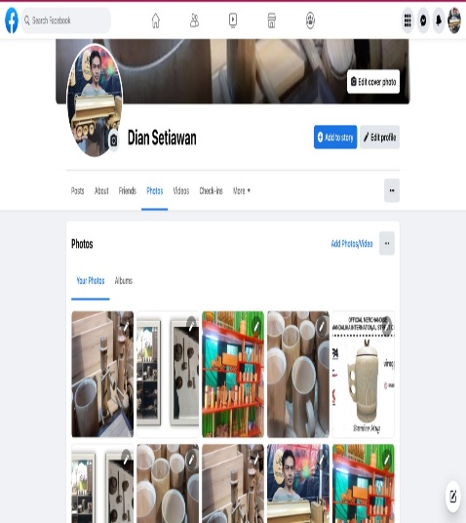
Picture 1. Facebook account

Production Activities
- Provision of Production
Equipment
The large number of requests for products makes it difficult for partners to fulfill them, this obstacle is due to the products made by partners being hand made products. So to fulfill the product process requires time for completion. Facing these problems, the team helps to overcome the problems faced by partners.
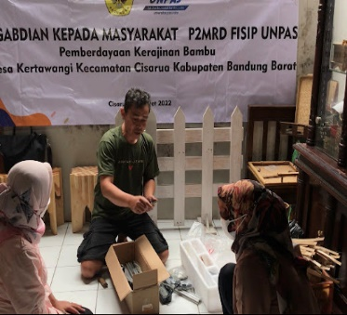
Picture 2. Bamboo production
Assistance given to partners to overcome the problems they face is by providing assistance in the form of machines. Machines given to partners or craftsmen are laser machines. This laser machine is a machine that can help to complete the writing or images that are in the product. 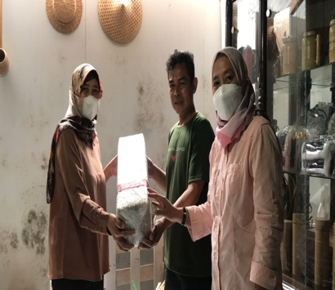
Picture 3. The team and partners
The method is for craftsmen to prepare laser machines and laptops and then make designs and laser machines to focus on the product. Automatically the laser machine and laptop will simultaneously form text or images according to what has been designed into the product. With a laser machine partners can paint the burn on the product with more accurate drawing speed and accuracy, reduce costs and more tidier

Simple bookkeeping activities
- Training
Then the Team carried out the next activity program, namely financial training. In this financial training delivered by Dr. Siti Patimah, SE., M.Sc. The training activity begins by giving partners an understanding of the importance of keeping records in running a business. The partners stated that while running the business the partners had received training on financial recording but were neglected due to their busy production activities.
Partners ask one of his relatives to help do the recording. Based on what has been conveyed by the partner, then the partner is given a little understanding of simple bookkeeping. This is so partners can do their own recording without having to ask for help from others. The form of recording only consists of a date column, an explanation column, an income column, an expenditure column and a balance column. Apart from that, partners are also given an understanding of determining the cost of production to make it clearer how much profit they get each month. Because partners only convey every month before the pandemic gross income of approximately 25 to.d. 30 million. Less costs, including the cost of salaries consisting of 5 employees, minus the purchase of raw materials, auxiliary materials, electricity costs etc.
The partner said that there is still money for children's school fees and daily living expenses. But after the pandemic, I had to sell my motorbike to pay for salaries, etc. Until finally there was no marketing and the product was not sold. However, there is still a way with collaboration. However, with such conditions, partners are still asked to carry out simple records so that it is clear what business they are carrying out.
b. Binteks
Continuing the previous activity, namely training, partners are given a simple bookkeeping method. In carrying out simple bookkeeping, partners understand how to record it, but it is difficult for partners to share time in recording because they are more focused on production.
An addition, an explanation and understanding of how to determine the cost of production for each product is also given. The output of community service activities can be seen in the table below:

No | Infromation | Before | After
1 | Marketing a. Training | Marketing is carried out by participating with groups of other craftsmen through the alibaba web www.bamboo/art/com | Already has its own online marketing feature through social media on Facebook and Instagram. With the IG username, diansetiwan_and face
2 | Production Production Equipment | 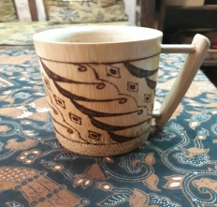  To create an image on the product. Using manual tools, with long workmanship, one day at the fastest for each product. | After using the machine:  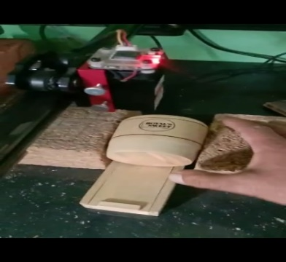  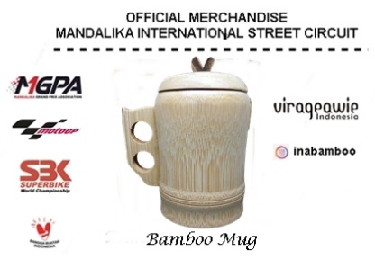
3 | Simple bookkeeping a. Training b. Binteks | There is no self-registration, more entrusting to other parties | - Understand simple bookkeeping consisting of numbers, dates, descriptions, debits and credits.  - Understand how to determine the cost of production which consists of raw material costs + Production Labor and Factory Overhead Costs.
Table 1. community service activities

D. Conclusion
Based on the results of the activities that the team has carried out, the following conclusions can be drawn: a) Service activities have been carried out in small handicraft businesses in Cisarua Village, Kertawangi Village, Cisarua District, West Bandung Regency. Partners have received marketing training, provision of production equipment and training as well as simple bookkeeping instructions. b) After the partner service activities are carried out, they can increase understanding regarding marketing, production and simple bookkeeping. Apart from that, by providing production equipment, partners can work on lasers on products faster and minimize production costs and work more neatly.

REFERENCES
Ahsanul Minan,2003,”Modul Pelatihan”diperoleh April 2014 dari https://docs.goegle.com:ahsanulminan.webs.com/modul/modul.
Rianingsih Djohani,2012,”Konsep Pendampingan Masyarakat” diperoleh 17 April 2014https://docs.goegle.com.riadjohani.files.wordpress.com/2012/konse p-masyarakat-pendampingan -masyarakat.

Rahmad Agus, 2013, “ Pengenalan Bisnis dan Pabrik Konfeksi “ diperoleh 2 April 2014 http :// www.pabrikkaosbandung.com/konveksi/pengenalan-bisnis-dan pabrik-konveksi

Info Bandung, 2013, “ Bisnis Usaha Konveksi Bandung” diperoleh 14 april 2014 http :// Infobandung.org/bisnis-usaha-konveksi-di bandung-1004 html.
http://www.pabrikkaosbandung.com/konveksi/pengenalan-bisnis-dan-pabrik-konveksi

