DEVELOPMENT OF E-WARONG KUBE PKH “SALUYU NGAWANGUN” SUB-DISTRICT OF NORTH CIMAHI, CIMAHI CITY
Yuce Sariningsih¹, Abu Huraerah², Erti Dinihayati³, Uga Pratama⁴
Social walfare science^{1,2,4} Business Administration³
Universitas Pasundan
yucesp@unpas.ac.id¹, huraerah_ks@unpas.ac.id²,
ertidinihayati@unpas.ac.id³

ABSTRACT

E-warong Saluyu Ngawangun is one of the e-warong located in Cimahi City, precisely in Sangkuriang Barat 3 , RT 2 RW 7 Kampung Anggaraja Cipageran North Cimahi which is running well in accordance with the purpose of the existence of the e-warong from the Ministry of Social Affairs operating not limited to only when there is a distribution of Non-Cash Food Assistance (BPNT) on weekdays, the e-warong also provides services to Beneficiary Families (KPM) optimally, although the e-warong administrators have activities outside of e-warong activities but the existence of e-warong - Warong Saluyu Ngawangun can be optimized according to the objectives of the Ministry of Social Affairs. The problems faced by KUBE PKH e-warong managers as partners based on research results are: low business management skills, low entrepreneurial knowledge, low knowledge of consumer behavior, low knowledge of financial accounting. The training method, aimed at transferring knowledge and technology (Science and Technology) in overcoming problems through increasing insight and understanding for partners. The implementation of the training is planned to be carried out in one room at the e-warong Saluyu Ngawangun, Cimahi City. For business management problems, information is given about business management capabilities related to understanding within the scope of management, namely Marketing Management, Capital Management, Risk Management, Business Plan. The entrepreneurship material provided is about social entrepreneurship activities, some entrepreneurial activities while for consumer behavior material, e-warong is introduced how to study consumer behavior in taking advantage of the existence of e-warong while the training material from accounting discusses petty cash recording or financial income and expenditure traffic. in e-warong. After the transfer of information is given, it is hoped that there will be a change in understanding of business management, e-warong income, as well as the participation of the e-warong manager, motivated to advance the e-warong business, having a clear financial bookkeeping writing system and expanding the reach of consumers of the beneficiary community. from e-warong.

Keyword: e-warong, Joint Business Group (KUBE), Family Hope Program

A. Introduction
Poverty alleviation is a major problem at the national level which is a top priority in the development of social welfare. This became the basis for the Ministry of Social Affairs to form a Joint Business Group (KUBE) in 2003. This program is intended as an effort to alleviate poverty in the form of an empowerment program for the poor through an integrated pattern between KUBE and Micro Finance Institutions (LKM).
The low level of income is one of the triggers for business failure at KUBE. Inadequate income and even then more are used to meet daily needs, so there is no more capital funds to buy raw materials for business continuity. Based on the research findings above, the Ministry of Social Affairs initiated the KUBE e-warong together with several state-owned banks with cashless and card models, KUBE e-warong players have money that is stored safely and cannot be reduced to buy daily necessities, and through the BISA card facilitated by BNI, it is hoped that the empowerment of the poor towards a prosperous society can be realized.
Cimahi City is the center of goods and services service activities in the western part of Bandung Regency. Industrial zones are evenly distributed in almost all areas. The highest industrial concentrations are in southern Cimahi, Leuwigajah and Central Cimahi. Industrial activities in Cimahi are dominated by textiles, clothing, and leather as many as 113 units or 28% of the number of small industries that exist. As for the medium and large scale, there are 92 industrial units. From the 2001 data, a significant contribution to building the economy of Cimahi City was the manufacturing sector (68.11%), followed by the trade, hotel and restaurant sector (15.23%). Meanwhile, other sectors (16.66%) include the building, electricity, gas and clean water, agriculture, services, finance, transportation and communication sectors.
Handling the Urban Poor which is implemented through the KUBE e-Warong activity which is carried out to improve the quality of life and welfare of poor families who live in uninhabitable houses and inadequate and slum environmental carrying capacity. It is hoped that this activity can have a positive influence on harmony, health and the spirit of working for poor families. e-warong Saluyu Ngawangun is one of the e-warong located in Cimahi City, precisely in Sangkuriang Barat 3 , RT 2 RW 7 Kampung Anggaraja Cipageran Cimahi Utara which is running well in accordance with the purpose of the existence of the e-warong from the Ministry of Social Affairs operating not limited to only when there is a distribution of Non-Cash Food Assistance (BPNT) on weekdays, the e-warong also provides services to Beneficiary Families (KPM) optimally, although the e-warong administrators have activities outside of e-warong activities but the existence of e-warong - Warong Saluyu Ngawangun can be optimized according to the objectives of the Ministry of Social Affairs.
This shows that group dynamics are optimal for achieving goals.

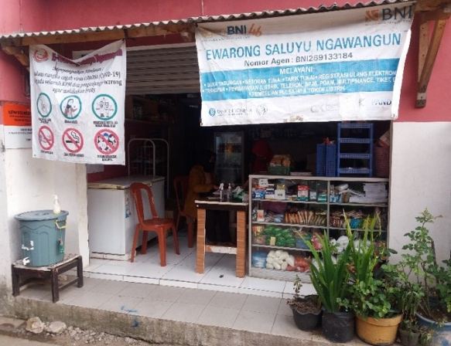
The problems faced by managers e- Warong KUBE PKH Saluyu Ngawangun as a partner based on the results of the research is the low group dynamics among members, which results in problems in the fields of business management, social entrepreneurship, introduction of consumer behavior and financial bookkeeping.
1. Low business management skills Business. Management ability is related to understanding within the scope of management, namely Marketing Management, Capital Management, Risk Management, Business Plan
a. Marketing Management Implementers and managers of e-Warong KUBE PKH are KUBE Services whose members come from PKH participants and recipients of Raskin/Rastra determined by the District/City Social Service. Each e-warong is allowed to carry out Productive Economic Enterprises (UEP), which is a series of activities aimed at increasing the ability to access economic resources, increasing economic business capabilities, increasing the productivity of economic business capabilities, increasing income and creating mutually beneficial business partnerships.

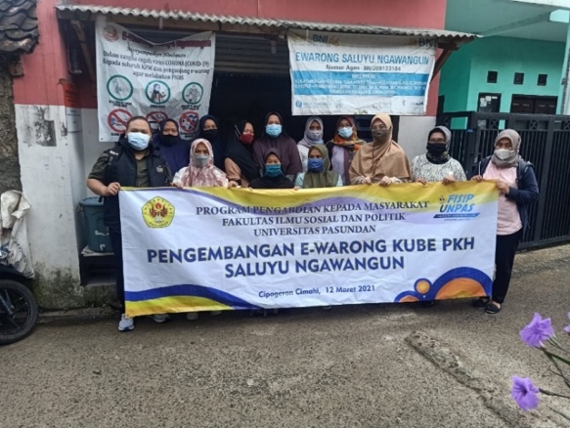

Productive Economics Business (UEP) allows KUBE e-warongs to increase the variety of products and services sold, not only to KPM but also to the general public, this has been supported by the existence of stalls and storefronts, but e-warong has not yet optimized the potential of the resources that have been provided. owned, including E-warong human resources. Micro-scale enterprises (micro-enterprises) are often constrained by various problems, especially in the field of marketing, especially in the conditions of having to compete with medium-scale companies or other large-scale industries [4]. Based on the research findings, it is found that networks of friends or relatives or acquaintances who create micro-scale businesses such as e-warong do not prioritize the importance of marketing communication as follows:
1. Strong branding and e-warong labels with more marketable labels to face competitors in surrounding stalls. This needs to be prepared because business people already have plans to sell processed foods as their business development.
2. Improved arrangement for all products sold.
3. Expanding partner networks other than BNI and Bulog so that supply remains stable.
4. There are clear rules for roles and coordination functions within the group, both in scheduling pickets at stalls and in profit sharing.
5. Training on marketing techniques for small-scale group businesses.
6. Expanding marketing communication models and channels to target a wider target audience.
b. Capital Management. The amount of e-warong assistance is Rp. 10,000,000,- (ten million rupiah for 1 (one) stall, with details for the rehabilitation of stalls, purchase of shelves, purchase of storefronts and other supporting facilities/equipment. The capital in the form of facilities owned by e-warong are
1) KUBE PKH stalls, 2) Place for display/storefront and storage of goods/shelves, 3) Agent nameplate, and 4) E-warong nameplate. While the capital in the form of tools is 1) EDC (Electronic Data Capture) machine, 2) Internet network, 3) Smartphone/tablet. Credit granted by the City Cooperatives and MSMEs Office Semarang can help increase business capital, sales turnover, and profits for micro-entrepreneurs in Pekunden Village, which can be seen from the differences in the variables of business capital, sales turnover, and profit between before and after getting credit [5]. Through counseling and increasing knowledge of e-warong actors, the credit system if the rules and regulations are complied with can increase capital capacity, as well as increase entrepreneurship of e-warong actors.
c. Risk Management The ability to understand Risk Management is very important, especially when dealing with problems with KUBE e-warong partners, namely with Banking (BNI, BRI, BTN, Mandiri), Perum Bulog and other distributors and cooperatives.
d. Business Plans; A business plan is needed for the development of a warung business even though it is still on a small and simple scale, so that e-warong managers can map the potential and optimize the available resources to achieve goals.
2. Low Entrepreneurial Knowledge knowledge of social entrepreneurship is very important because more KUBE e-warong actors give up easily when faced with problems and challenges. The success of e-warong will depend on how strong the actors show their entrepreneurial spirit in the form of creativity and innovation in carrying out their business.
3. Low knowledge of consumer behavior. In developing an e-warong business, it is necessary to know the behavior of consumers who take advantage of the existence of an e-warong so that in its development it can meet the expectations of consumers, because in this case e-warong consumers are not only limited to Beneficiary Families (KPM) but all members of the community who are around the e-warong environment. E-warong must understand the diversity and similarity of consumers or consumer behavior in order to be able to develop their business according to their wishes.

B. Method of Implementation
The training method, aimed at transferring knowledge and technology (Science and Technology) in overcoming problems through increasing insight and understanding for partners.
The implementation of the training is planned to be carried out in one room at the e-warong Saluyu Ngawangun, Cimahi City.

The approach method is determined by the team to overcome the problems, and the solution is to achieve the output targets that have been set. For business management problems, namely: Business management capabilities related to understanding within the scope of management, namely Marketing Management, Capital Management, Risk Management, Business Plan.
PROBLEM :
1. Low business management skills
2. Low entrepreneurial knowledge
3. Low mastery of consumer behavior
4. Low knowledge of financial bookkeeping
METHOD STAGE
Increasing group capacity through:
1. Marketing Management Training
2. Entrepreneurship training 3. Consumer behavior pattern recognition training 4. Financial bookkeeping training
SOLUTION 1: Increased knowledge of business management (Marketing Management, Capital Management, Risk Management, Business Plan
SOLUTION 2: Strengthening the entrepreneurial spirit
SOLUTION 3:
Increased mastery of consumer behavior
Continuity:
1. PKH facilitators continuously provide education to KUBE e-warongs
2. The PKH Team and Facilitator monitor and evaluate progress after 3 months
SOLUTION 4: Strengthening knowledge of financial bookkeeping
The entrepreneurship material provided is about social entrepreneurship activities, some entrepreneurial activities while for consumer behavior material, e-warong is introduced how to study consumer behavior in taking advantage of the existence of e-warong while the training material from accounting discusses the recording of petty cash or income and financial expenditure traffic. in e-warong.
C. Result and Discussion
e-Warong Saluyu Ngawangun was established in 2017. This e-Warong is one of the E-Warongs located in the Cimahi City area. The purpose of establishing this E-Warong is to improve the welfare of the Beneficiary Families (KPM) in the area around the e-Warong. This e-Warong was established accompanied by a Social Assistant and consisted of 10 people who were KPM from the Family Hope Program (PKH). The administrators of this E-Warong are: Chairman: Yuningsih Treasurer : Yeni Secretary : Nurhayati Member : Yanti Yulianti Laela sari Nurhalimah Dedeh Erni Rohayati flat sopianti Nenden kuraesin.
This e-warong is engaged in the grocery shop business that provides various kinds of daily needs, members of this e-warong always take turns to look after the shop, coordinated by the group leader, Ibu Yuni, this e-warong can run well.
The members of this e-warong do not have a job, they are housewives who are at home. Based on the priority issues above, to increase the capacity and business development of the partner group, Dissemination is needed, which is an activity aimed at the target group of partners so that they obtain information, raise awareness, receive, and ultimately utilize the information.
Training and mentoring are carried out to partners. The materials provided are in the form of:
1. Materials on Business Management
2. Materials on Social Entrepreneurship
3.Material on Consumer Behavior Patterns
4. Material on Petty Cash Bookkeeping For Business Management Problems, material on Enhancing Entrepreneurial Motivation, Enhancing the Right Business Management Capacity for Partners, Preparation of a Business Plan covering all aspects of the business, (market and marketing aspects, operational aspects, technical production,
The material on entrepreneurship given to e-warong managers is about entrepreneurial activities ranging from socialization and coordination, processes to the output of these entrepreneurial activities. As for the training on consumer behavior material, e-warong managers are explained about how to study consumer behavior patterns in this case the surrounding community in taking advantage of the existence of e-warong in their environment.
Accounting materials explain how to make an opening report in the form of recording expenditure and income in the form of petty cash. For this training activity using double blinds where for social entrepreneurship training using an online method considering the conditions during the Covid-19 pandemic it is not possible to carry out on-site training.

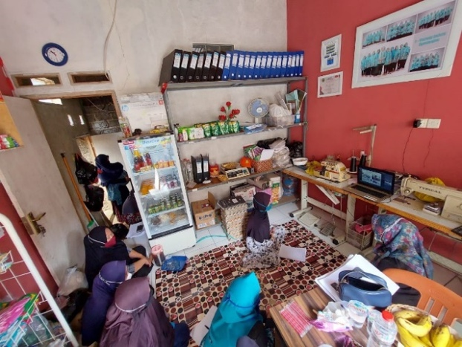
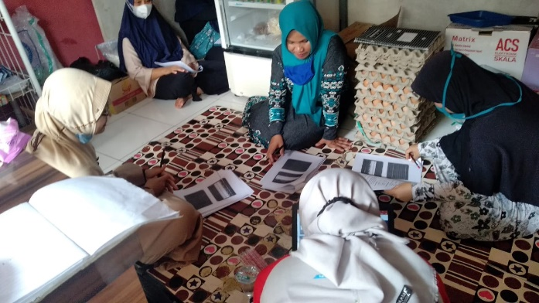
Condition After Program
Understanding of business management (40%)
Understanding of business management (80%)
E-warong income (Rp. 750.000,-/month)
E-warong income (Rp. 5.000.000,-/month
Participation (2 Persons)
Participation (10 People)
Do not have financial books
Have financial books
Range (2 Km)
Range (7 Km)
Condition Before Program
Furthermore, to simplify, lighten, streamline, connect, get, and have something that partners need. This facilitation and mediation approach for partners is used in overcoming problems and achieving targets and outcomes, so we provide assistance for filling basic necessities to complete goods sold at e-warong. 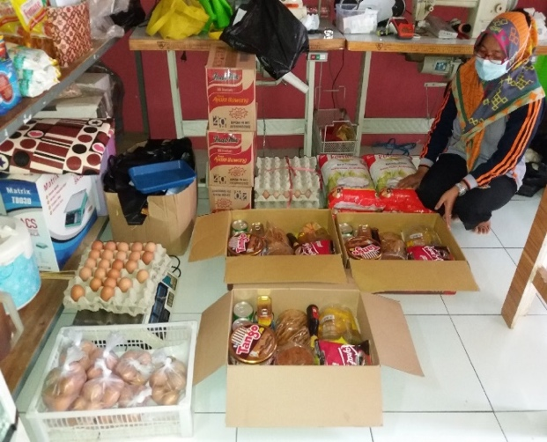

Success will be seen from the distance where is the achievement of the condition of e-warong after activities, which are described below.

The picture above shows that it is hoped that changes will occur before and after the service is given, judging by their understanding of business management, which at first they did not understand about business management from e-warong, it is hoped that after receiving training there will be an increase in understanding, as well as e-warong income.
Originally in a month e-warong earns Rp. 750,000 after receiving mebako assistance is expected to increase to Rp. 5,000,000 per month as well as the participation of the e-warong manager, it is hoped that all group members after receiving training on social entrepreneurship will be motivated to advance their e-warong business.
Meanwhile, e-warong which initially did not have a clear financial accounting writing system, after receiving training, the e-warong will have a detailed and systematic financial opening system as well as the reach of consumers who are beneficiaries of e-warong. Originally only the PKH beneficiary group, with training to recognize consumer behavior patterns, it is hoped that e-warong can expand its business into the environment around the e-warong.

D. Conclusion
Conclusion The development of E-Warong Kube PKH Saluyu Ngawangun, Citeureup Village, Central Cimahi District, Cimahi City is carried out by providing training with the following materials:
1. For Business Management Issues, material regarding: Increasing Entrepreneurial Motivation which discusses increasing the correct Business Management Capacity for Partners is discussed. Preparation of a business plan which includes all aspects of the business, (market and marketing aspects, operational aspects, technical production,
2. The material on entrepreneurship given to e-warong managers is about entrepreneurial activities starting from socialization and coordination, processes to the output of these entrepreneurial activities.
3. As for training on consumer behavior material, e-warong managers are explained about how to study consumer behavior patterns in this case the surrounding community in taking advantage of the existence of e-warong in their environment.
4. Accounting materials explain how to make an opening report on how to record expenses and income in the form of petty cash. And for suggestion, partners should have entrepreneurial abilities so that they have the innovation to choose the type of business to develop their e-warong business. Also, partners should explore having a Market Network and Business Network, especially in online media and implementing E-Commerce features in their marketing
REFERENCES
[1] A. B. Sinaga and Sumardjo, “Jurnal Penyuluhan,” J. Penyuluhan., vol. 3, no. 1, p. p.18-23, 2007.
[2] H. Yasin, “Upaya Strategis Pemberdayaan Ekonomi Masyarakat Melalui Kelompok Usaha Bersama (KUBE),” J. Adm. Publik, vol. 5, no. 1, pp. 38–41, 2015.
[3] P. Pelaksanaan, “e-WARONG KUBE,” no. 28.
[4] D. R. Hidayati, “Strategi Komunikasi Pemasaran Usaha Skala Mikro (Micro Enterprise) Kub Bajrah Gunah Klampis Bangkalan Pada Produk Terasi, Petis Dan Kerupuk Ikan,” Agriekonomika, vol. 5, no. 1, p. 104, 2006.
[5] F. Ekonomika, D. A. N. Bisnis, and U. Diponegoro, “BAGI KELOMPOK PELAKU USAHA MIKRO OLEH DINAS KOPERASI DAN UMKM ( Studi Kasus : KPUM di Kelurahan Pekunden , Kecamatan,” vol. 1, pp. 1–15, 2012.
[6] M. R. Roosdhani, P. A. Wibowo, and A. Widiastuti, “‘Informasi Dan Komunikasi Pada Usaha Kecil,’” J. Din. Ekon. Bisnis, vol. 9, p. 89–104, 2012.

