Development of Tourism Business Potential
Through the Use of Smartphones in Market Tourism Warnasari Village District of Bandung

Yogi Muhamad Yusuf¹, Charisma Asri Fitrananda²,

Mochamad Iqbal³, Vikry Abdullah Rahiem⁴
^{1,2,3,4}Universitas Pasundan, Bandung, Indonesia
¹yogimyusuf@unpas.ac.id, ²charisma.asri@unpas.ac.id,
³moch.iqbal@unpas.ac.id, ⁴vikry.ar@gmail.com

ABSTRACT

This service aims to provide socialization on the use of smartphones as a means of promotion in the potential tourism of Warnasari Village tourism business operators, Pangalengan District, Bandung Regency. The tourism businesses managed by tourism businesses and Youth Organizations in Warnasari Village are Situ Cileunca, Rafting, Cukul Sunrise Point and Agro Tourism. Business operators have developed several types of potential tourism in the Warnasari Village with a target market for the lower middle class. But because of the growing demand from consumers in terms of the tourism sector, the target market wants to be changed to the upper middle class. The problem that is owned by partners is the lack of ability in terms of the use of smartphones such as photo editing, video editing and the use of social media. Community service activities using a contextual approach that is providing theoretical material first and followed by workshops directly editing photos and videos using a smartphone and uploading his work produced by partners. Then proceed with the method of briefing photo and video editing techniques, and the use of social media in potential tourism marketing in Pangalengan.

Keywords: tourism business, smartphone, photo, video

A. Introduction
One of the important sectors and its contribution in realizing the national economic development goals is Youth Organization. The targets are such as economic growth, employment opportunities, increasing foreign exchange and regional economic development, it is expected that tourism businesses have the ability to participate in spurring national economic growth. The development of the small and medium business sector which is managed by tourism businesses, especially in the Warnasari Village is part of the Pangalengan District, Bandung Regency, West Java Province.
Warnasari Village has great potential as an area of ​​agricultural product production that can be developed as an agro-industry and agro-tourism. In addition to rice and crops, which are generally agricultural products, Warnasari Village is also known as a producer of several agricultural products for horticulture. In an effort to develop a farming business in Warnasari Village, basically the involvement of actors consisting of various parties such as product producers, processors, traders, distributors, importers and exporters is needed. This business actor is a component or subsystem that forms an agribusiness system. The system, in the coming years is expected to function more optimally in order to realize the level of community welfare. Therefore,
The business actor is a collection of regional youth organizations that develop several kinds of tourism potential in the Warnasari Village which has a target market for the middle to lower classes. But because of the growing demand from consumers in terms of the tourism sector, the target market wants to change to the upper middle class. The businesses undertaken by Youth Organization in Warnasari Village are Situ Cileunca, Rafting, Cukul Sunrise Point and Agro Tourism.
Warnasari Village, which is not the whole region can be developed for agriculture, as well as the diversity of commodities at the farm level and government policies that are not the same, has led to differences in perceptions about the right commodities to be developed in Warnasari. So to study the superior commodities. Warnasari Village which is suitable with agro-climate in developing horticulture farming, needs a series of intensive activities.
Warnasari Village is actually located in a strategic area that is close to the tourism potential of Situ Cileunca. Mountains and natural beauty of Warnasari, also support the development of the tourism sector. This can make the Warnasari Pangalengan area a tourism area. But so far the community as well as the village government as if only as "spectators" in the management of Situ Cileunca tourism. The community hopes to be able to contribute and become a part in the development of the Situ Cileunca region as well as the potential resources of the Warnasari Village in general.
One of the most important empowerments for the community to do in Desa Warnasari is to prepare everything, both human resources and infrastructure, in managing the potential of existing natural resources in order to increase the tourism potential there. Based on this, it is important for the people in the Warnasari Village to gain stock of understanding managing the potential of highly competitive tourism as well as increasing the potential of processed agricultural products which are the advantages of the Warnasari Village Pangalengan.
From the observation of the dedication team, the Village Government hopes to have a reference to determine the direction of the policy relating to the tourism sector. Business activities carried out by tourism businesses have been running since 2004 and have experienced positive developments. But with the problems faced, as follows:
- Partners do not have the ability to edit photos and videos in creating tourism promotional content, especially having limitations in pouring ideas, use of smartphones that have not been maximized and limited labor.
- Partners have not been able to bring out the characteristics of the tourism business that they manage, especially in the promotion section.
- Knowledge, capability and management of social media partners are still limited, especially in introducing superior tourism potential to their wider target audience through targeted promotional activities both offline and online. In particular, partners do not yet have sufficient knowledge and ability to access social media to market their tourism business online.
Based on the problems that have been identified in the two partners, then to determine an agreement in determining priority problems that immediately find a solution, with the aim of improving the management of tourism businesses in Wanasari Village, Pangalengan District, Bandung Regency as follows: assistance in the editing process and tourism promotion video using smartphone; improving the management of tourism businesses for both partners requires optimization of HR qualifications, by increasing creativity and innovation, as well as enhancing the spirit of entrepreneurship; and facilitate the promotion of tourism business activities using online media (YouTube and social media).

B. Method of Implementation
There are three stages of activity methods used by the team: the approach method, the direction method and the mentoring method.
- The approach method used for community service outcomes in the Warnasari Village, is applied to find out the target audience for Community Service so that the implemented knowledge can be appropriate to the Partners. The method of approach is done by observing in advance and opening a discussion session with partners about what is the problem of partners.
- Editing Method of editing technique is in the form of photo editing training using a smartphone using the Photo Editor, Picsart and Canva applications. This briefing is intended for partners to understand the steps in editing photos and videos, such as: taking pictures or travel photos, determining content, creating campaigns, making travel vlogs, strategies to have as many followers as possible through Instagram, Twitter, Facebook fanpage, YouTube ; and others.
- The assistance method is carried out so that it can implement tourism business management better, in order to achieve the expected business goals and provide solutions to the problems encountered. This method is directly practiced by instructors with partners so partners can immediately understand the photo and video editing application on smartphones. In addition, partners can immediately make a show in the form of a vlog to market tourism potential in Pangalengan and can discuss if there is something that is not yet understood.
The types of outcomes in the Community Partnership Program on Youth Organization in the Warnasari Village are as follows: partners are able to show special characteristics (branding) through increasing the qualifications of workforce expertise (HR) in the field of tourism promotion, partners are able to edit photos and videos for the benefit of tourism promotion by using smartphones and partners are able to introduce tourist attractions with the YouTube platform and social media.

C. Result and Discussion
Community Service Activities have been carried out at the location of Warnasari Village, Pangalengan District, Bandung Regency and take place according to a schedule of 4 weeks starting from the preparation, implementation and reporting stages. In the preparation stage, the team has determined the time the activities will start to be carried out, in the initial stages the team coordinates with partners to immediately carry out activities in accordance with the activity schedule. The first thing to do is coordinate with the village, in this case the team is assisted by P3M FISIP Pasundan University. The team and P3M visited Wanasari Village to find out what problems the partners had. This activity is the second year in the implementation of community service in the same place, meaning that this community service is a follow-up program of service in 2019.
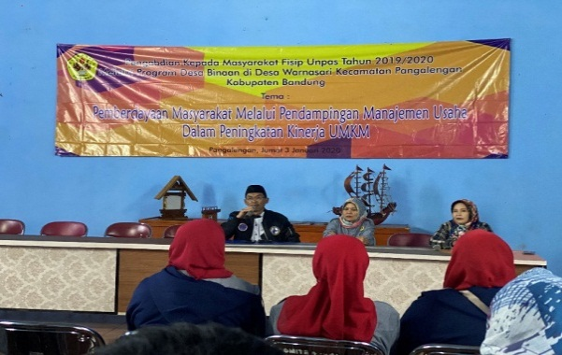
Figure 1. Implementation of Community Service

When the team made observations in Desa Warnasari and conducted interviews with the village and youth groups, there were a number of problems that could be helped by the ability of our service team, namely it was known that the partners did not have the ability to edit photos and videos for tourism promotion content, especially having limitations in pouring ideas, as well as the use of smartphones that have not been maximized. Partners also have not been able to bring out the characteristics of the tourism business that they manage, especially in the promotion section. The ability and management of partners' social media is also still limited, especially in introducing superior tourism potential to their wider target audience through targeted promotional activities both offline and online. Especially,
For field observations, partners participate in determining the time and place of implementation. For more details, the implementation phase of the PKM activities the team is doing is visiting tourist partners and their management offices located in Warnasari Village, Pangalengan District, Bandung Regency. During several visits, the team looked at the place of business operators, the majority of which were held by Youth Organization which was used for business production such as coffee, chips, tomatoes, vegetables and tourism. The team saw the tourism potential that could be promoted through social media, such as Situ Cileunca, Rafting, Cukul Sunrise Point and Agro Tourism.
Besides seeing how the management of business undertaken related to HR / employees who work in the management of these tourist attractions. Within a day the tourist attractions can be visited around 30-100 people per day, while for holidays can be more than 100 people. The employees who assisted the partners were mostly members of Warnasari Village and surrounding areas. However, employees in the tourism sector do not have educational qualifications yet in experience in strategies in the field of tourism or offline and online marketing. Therefore, specifically in the field of marketing / promotion, partner stilltake advantage of word of mouth networking or ask family members who are quite tech-savvy and have the desire to learn new things.
One of the ways to improve productivity and business management in the tourism sector is to increase human resource qualifications. On this occasion, the team invited partners to be able to participate in the application of science and technology in the form of photo and video editing to create tourism content and market it through social media that is facilitated in this PKM activity. Previously, the team had provided online marketing training conducted to provide partners with an understanding that marketing techniques of business results are needed through online media because this marketing problem is the most crucial problem faced by partners, due to the limitations of electronic devices and understanding of the digital world.
So far the two partners do not have social media and e-commerce accounts in their marketing, only conventional marketing such as exhibitions / events, personal selling and display. While the market has changed, the target market is not only conventional, but many target markets in the digital age. Online marketing training is given in theory and practice in two different meetings. For theoretical training, partners are given material on understanding marketing strategies in the digital age, then on social media accounts, e-commerce, websites, SEO and digital target markets. As for practice, partners created social media and e-commerce accounts and how to apply them directly by the instructor.
In the implementation of dedication in order to develop the potential of tourism businesses in using a smartphone, this was conducted on Tuesday, February 26, 2019 at the Multipurpose Building, Warnasari Village, Pangalengan District, Bandung Regency. The event began at 07.00 until 16.00 WIB, attended by 25 participants. Based on the problems described earlier, through these PKM activities the resulting outcomes are as follows: partners are able to show their characteristics (branding) through increasing the qualifications of labor expertise (HR) in the field of tourism promotion, partners are able to edit photos and videos for the benefit of tourism promotion with using smartphones and partners are able to introduce tourist attractions with the YouTube platform and other social media.
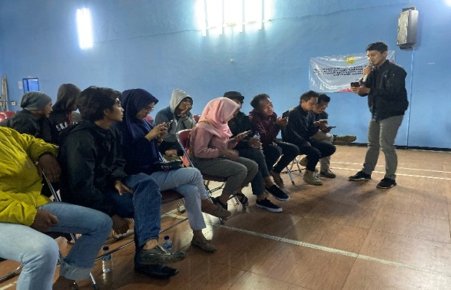
Figure 2. Material Explanation Process

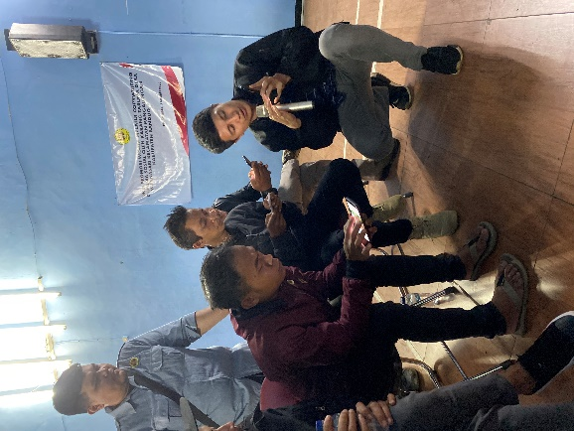
Figure 3. Resource persons Dr. Yogi M. Yusuf, M.Pd

The material provided by the resource person is Dr. Yogi M. Yusuf, M.Pd is about editing photos and videos through smartphones. This material is given directly both in the form of theory and practice so that participants can understand directly in accordance with each smartphone they have.
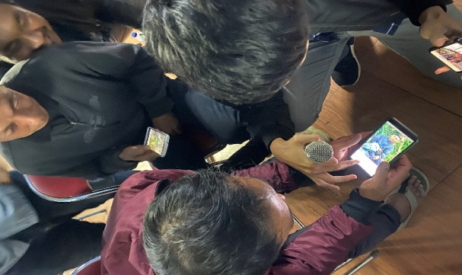
Figure 4. Participants Use Smartphones

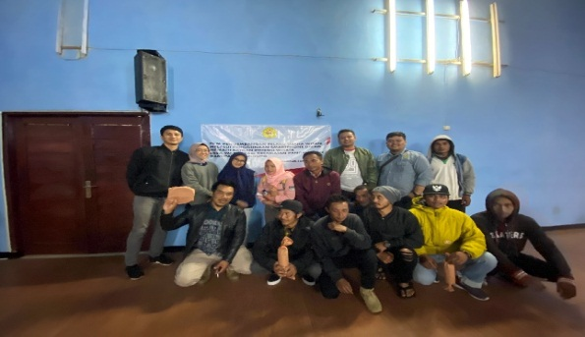
Figure 5. Participation in Service

With the many benefits generated by the tourism sector, the government has decided to make tourism a key sector line. Therefore, efforts are needed to market a tourist destination so that it is better known by both domestic and foreign tourists. In addition, efforts to market destinations are also useful so that they have a longer life span.
There are several aspects and stages that need to be considered for marketing. If you have heard of Positioning-Differentiation-Branding according to Hermawan Kartajaya, those three bases are used in marketing, including inmarketing tourism destination.
After know the Positioning of a tourism destination (how a destination wants to be known or remembered by consumers), then know the Differentiation (differentiating a destination from other competitors' destinations), what needs to be done next is Branding. When discussing branding in full, of course we need a special thick book to discuss the topic. Broadly speaking, a brand is a company promise or consumer experience associated with a product. Building a brand cannot happen overnight, building a brand is a long and difficult process. But success in building this brand can produce long-term relationships.
Brands in a tourist destination are needed to face competition. One of the competition that occurs between destinations is the unknown of a destination compared to other destinations, even though both destinations offer similar, or different, products but with their own uniqueness. Destination brands can make it easier for tourists to distinguish a destination from other destinations.

D. Conclusion
Based on the activities that have been carried out by the Community Service Team in the Warnasari Village, Pangalengan District, Bandung Regency, it can be concluded that the implementation of increasing HR qualifications in the form of developing the potential of tourism businesses through the use of smartphones in marketing tourism has been carried out smoothly.
Optimizing performance through enhancing HR creativity and innovation, namely through understanding the concept of editing photo and video tourism content as well as increasing the ability of social media marketing, so partners can introduce their tourism business more broadly and create a destination branding through online media. From the implementation of this PKM activity, there are a number of suggestions that can be used as input for partners, namely partners are advised to always innovate in creating tourism content and improve HR qualifications that can follow the latest development trends (up to date). Marketing of tourist businesses conducted by partners must always followtimes that is having the ability in the field of online and digital media, so as not to compete with other companies. The government is expected to pay more attention to small businesses around the tourist area, thus helping to raise the tourism potential of the region.

REFERENCES

Kertamukti, Rama. (2015). Strategi Dalam Periklanan. Jakarta: PT. Raja Grafindo Persada. Kotler, Philip; Armstrong, Garry, 2008. Prinsip-prinsip Pemasaran, Jilid 1, Erlangga, Jakarta.
Bungin, Burhan. (2015). Komunikasi Pariwisata. Jakarta: Prenada Group
Deddy, Mulyana (2005). Ilmu Komunikasi. Bandung: PT Remaja Rosdakarya
http://www.kemenpar.go.id/

