PKM DEVELOPMENT OF BUSINESS OPPORTUNITIES FOR COFFEE FARMERS IN WARNASARI VILLAGE, SUBDISTRICT PANGALENGAN, DISRICT BANDUNG

Dhini Ardianti¹, Ida Hindarsah², Taufik Hidayatullah³, Vera Hermawan⁴
^{1,2,3,4} Universitas Pasundan, Bandung, Indonesia
¹dhini.ardianti@unpas.ac.id , ²ida.hindarsah@unpas.ac.id ,
³taufik.hidayatullah@unpas.ac.id , ⁴vera.hermawan@unpas.ac.id

ABSTRACT

Pangalengan is one of the districts in Bandung Regency which is an agricultural center. One of the potential products in the Pangalengan area is Pangalengan coffee which is well known to foreign countries. However, not all of the village areas in Pangalengan coffee farming have not been made a top priority, so there is still a need for coaching and mentoring as the PPM team of this group is serving together with the PPM team of the Faculty of Social and Political Sciences (FISIP) Unpas in February 2019 in Warnasari Village, Pangalengan District Bandung. The problems identified in the partners are human resources, raw materials, production, products, and marketing. The target or partners in this activity are coffee farmers in the Warnasari Village, Pangalengan. The method of activities includes social mapping related to the identification of problems faced by coffee farmers and FGDs with entrepreneurship material. The results of this period PPM devotion shows a change in the mindset of coffee farmers to turn coffee into a priority or mainstay of the region's commodities, in addition to the awareness related to the increasing spirit of entrepreneurship desiring to process coffee yields with variant forms in the future. The next target is the need for further service programs from the social mapping and FGD results from this period. in addition there is also an awareness related to the increasing spirit of entrepreneurship in wanting to process coffee yields with variant forms in the future. The next target is the need for further service programs from the social mapping and FGD results from this period. in addition there is also an awareness related to the increasing spirit of entrepreneurship in wanting to process coffee yields with variant forms in the future. The next target is the need for further service programs from the social mapping and FGD results from this period.

Keywords: PKM, Business Development, Coffee Farmers, Warnasari, Pangalengan

A. Introduction
Pangalengan is one of the sub-districts in Bandung Regency which is known as an agricultural center area. One of the potential products in Pangalengan is Pangalengan Coffee which is well known to foreign countries. However, not all village areas in Pangalengan have yet to make coffee farming as a top priority, so they still need guidance and assistance. Through this activity, our group PPM team aims to carry out the tri dharma of tertiary institutions, the Community Partnership Program (PKM) together with the PPM team of the Faculty of Social and Political Sciences (FISIP) Unpas in February 2019 in Warnasari Village, Pangalengan District, Bandung Regency.
Pangalengan is a sub-district in Bandung Regency, which is located in the south, approximately 29 km from the district office. It is limited by Cimaung District to the north, Talegong District to Garut Regency to the south, Pasirjambu District to the west, Kertasari District and Pacet District to the east. Pangalengan District is divided into 13 villages namely Lamajang, Margaluyu, Margamekar, Margamukti, Margamulya, Pangalengan, Pulosari, Sukaluyu, Sukamanah, Tribaktimulya, Wanasuka, Warnasari, and Banjarsari.
Pangalengan is an agricultural center. The agricultural sector contributes the largest of the total regional gross domestic product of Pangalengan District even to the Regency level, the third largest contributor after the industrial sector (without oil and gas), mining and quarrying (oil and gas). Seeing the potential that exists, the agricultural sector is a sector that deserves more attention, both from the regional government and the agricultural community itself.
Warnasari is one of the Villages in Pangalengan District, Bandung Regency. Warnasari Village is actually located in a strategic area that is close to the tourism potential of Situ Cileunca. Mountains and natural beauty of Warnasari, also support the development of the tourism sector. This can make the Warnasari Pangalengan area an agricultural tourism area. One of the most important empowerments for the community to do in Desa Warnasari is to prepare everything, both human resources and infrastructure, in managing the potential of existing natural resources in order to increase the tourism potential there. Based on this, it is important for the people in the Warnasari Village to get a stock of understanding managing the potential of highly competitive agro-tourism as well as increasing processed agricultural and plantation products which are the advantages of the Warnasari Village in Pangalengan.
In addition to rice and secondary crops, which are generally agricultural products, Warnasari Village is also known as the best coffee producer in West Java and several other horticultural agricultural products. In an effort to develop a farming business in Warnasari Village, basically it requires the involvement of actors consisting of various parties such as product producers, processors, traders, distributors, and so on. Through Community Service (PKM) of FISIP Unpas, the team of this group focused on developing the Coffee business in Warnasari Village, because basically the people who cultivate plantations or vegetable farming also plant coffee plants in their own yards. In the sense that the coffee they harvest is still not optimized into a business or main income.
Based on the initial mapping in the field, there are manyCoffee plants are spread throughout each community's property. However, these coffee farmers are still unable to process coffee yields, they only process limited to the process of dried coffee beans manually. Starting from this, then identified the problems faced by partners, as in the following table below.

Table. 1
Problems Identified To Partners

No | Problem | Problem Details
1 | HR issues | Average elementary / junior high school education qualifications, insight limited  do not have competency or excellence (limited ability and will), this has the opportunity to be developed through training (training) or technical assistance:  Not yet the emergence of entrepreneurship motivation (entrepreneurship) for Coffee Farmers; Opportunities and Partnerships, Production Processes, Product Innovations
2 | Problem  Raw material | Managing the availability of raw materials (related to the growing season) and selecting the quality of raw materials
3 | Production Problems | Limited production capacity of production equipment such as: coffee pulping machines, spinners or dryers, etc.
4 | Product Problems | Limited products in terms of types of processed creativity or product innovation
5 | Marketing Issues | Only sold to dealers and has never been promoted in exhibition activities or the like; do not have a specific packaging or packaging so that it can be easily promoted even wider; haven't used a partnership, e-commerce account or social media.
Source: PPM Team Mapping Results, 2019.

To achieve the expected target, the team offers several solutions according to the problems faced by partners, including:
- Providing entrepreneurial knowledge and motivation for coffee farmers, opportunities and partnerships, production processes and product innovation.
- Providing training, bintek and partnership assistance / collaboration with various parties in the framework of marketing / distribution of production results.
The expected output target in this activity as a whole is to increase the ability of HR to have an entrepreneurial spirit, target market, production capability, thus the facilities and investment value will also increase. The steps taken are as follows:
- Warnasari Village Coffee Farmers Partners are able to understand the importance of entrepreneurship, especially in managing coffee yields.
- Partners are able to increase production capacity and quality; able to increase the quantity of coffee trees in each resident's house, (ranging from nurseries, planting and maintenance of coffee trees).
- Partners are able to understand the production process well by collaborating with the coffee community with regard to product knowledge.
- Partners are able to make product innovations (diversification of products including processing from beans to coffee grounds, taste, as the final stage partners are able to make a naming / brand product).

After the targets set in the community service series have been achieved, the benefits or outcomes will be in the form of:
- Institute of Social and Political Sciences Faculty of Pasundan University which is the initiator and executor of Community Service activities as one of the Tri Dharma of Higher Education.
- Lecturers, through this activity can develop social insights among lecturers and students, so that close and productive communication can be established between universities and the community to enhance campus participation in empowering the wider community; in this case the resulting output is in the form of scientific publications in the ISSN journal.
- Warnasari Village residents, they get knowledge and awareness about the need to improve welfare through business development of coffee yields that can be a superior commodity in the region.
- Residents of Pangalengan and West Java in general, through partnerships with the coffee processing community, are a starting point for expanding market share, as well as the need for publicity through online mass media, to demonstrate the superiority of Warnasari Village's Pangalengan Coffee.

B. Method of Implementation
In an activity a clear audience is needed, not least in the community service activities. The target audience in this community service activity are residents of Warnasari Village, especially Coffee Farmers in Warnasari Village, Pangalengan District, Bandung Regency.
The implementation method used includes several stages, namely the preparation and observation stages, deep interviews, social mapping & FGD, and the evaluation stage.
The preparation and observation phase, at this stage the Team conducted several small surveys by visiting several locations directly. The findings of the observation show that many residents have coffee plants in their yards. However, not all hamlets have warehouses for processing coffee yields, even if there is only one in Hamlet 1 and even then with limited conditions and what they are in accordance with the findings of the problems outlined above. This makes the Team consider this location to be the location of community service activities.
Then a deep interview was conducted on several residents who were coffee farmers, especially in Hamlet 1, how they carried out the production process, from harvesting to being ready for distribution in the form of seeds and other processed forms.
The next stage is the core activity of community service activities, namely social mapping related to problems and obstacles faced by partners in handling and processing coffee yields. In this stage, the team simultaneously provides informal entrepreneurial motivation, through a Focus Group Discussion (FGD) on how to make an effort from coffee harvesting and create business networks among coffee farming communities. This activity is carried out in 2 places / locations, namely by gathering coffee residents / farmers in the Village Hall and in the Warnasari Village coffee bean collection warehouse.
The final stage is the evaluation stage where community service activities that have been carried out are evaluated with partners. The partners here are coffee farmers and also residents and village officials who support the coffee business in the Warnasari Village, Pangalengan District, Bandung Regency.

Figure 1.
Activity Method

The implementation of Community Service activities was carried out in the Warnasari Village, precisely the location of the activities was centered in the Warnasari Village Office Hall and Dusun 1 Coffee Warehouse in Warnasari Village, Pangalengan District, Bandung Regency. Overall, the implementation of this activity requires a time allocation of 3 (three) weeks, starting from preparation and observation, deep interviews, core activities in the form of social mapping, namely in the form of focus group discussions (FGD), and evaluation stages. Various operational activities and detailed as shown in the table below.
Table 2
Schedule of activities
No. | Activity | Week to
 |  | 1 | 2 | 3
1 | - Preparation and Observation Stage  - Deep interview against local residents (Village Heads & Hamlet Heads) and Warnasari coffee farmers
2 | Social Mapping & FGD Stage:  - Inventory of problems faced by partners  - Discussions related to entrepreneurship motivation and coffee entrepreneurship development
3 | Evaluation Phase:  - Evaluate PPM program activities with partners

C. Result and Discussion
The implementation of this community service activity lasts for 3 (three) weeks. The activity was divided into three stages, namely the first stage was the initial stage in the form of observations and small surveys by interviewing the Kadus (Village Head) and approaching the Village Head. The second stage is the stage of core activities, and the last stage is the evaluation of activities with partners.
In the core stage, the implementation of community service activities was held on Wednesday, February 27, 2019. The implementation of the FGD as well as the opening of the Community Service program together with the other Community Service teams of the Warnasari Village community group. The program was held from 08.00 to 11.00 West Indonesia Time, in the Hall of the Warnasari Village Office, then reviewed the coffee production process in Hamlet 1 which is approximately 1 km from the Hall location. Community service activities in the form of FGDs containing material on entrepreneurship and partnerships. The FGD was attended by villagers who had an interest in developing the coffee business and also included the coffee farmers themselves. In this FGD activity targeted participants who follow have an entrepreneurial spirit, motivation to make products or creativity from coffee, thus not just planting-drying-selling only. The FGD activities were attended by 10 participants. Participants who attended consisted of the Village Head, the Kadus (Hamlet Head) of 3 Hamlets, Karang Taruna representatives, PKK representatives, and other residents who were coffee farmers or who were interested in developing coffee.
Activities in the form of informal discussions through FGDs contain entrepreneurship material and various issues related to the processing and distribution of coffee in the warnasari village. The results of the FGD were then compiled as a social mapping as a reference material for further service activities.
The activities of the dedication team were carried out together with the dedication team of the Communication Study Program group which took place in the Warnasari Village Hall from 09.00-12.00 WIB. The opening was started with an event from the P3M FISIP Unpas team, then separated / separated by room. The dedication program for our team was held in the Warnasari Village office room. After the participants gathered, the team started the FGD event led by the Chairperson along with the team implementing members.
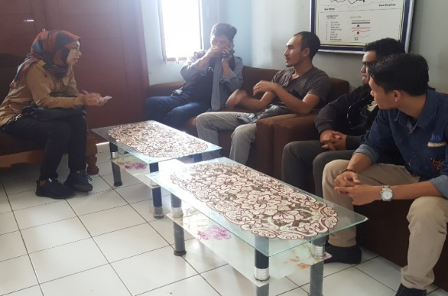

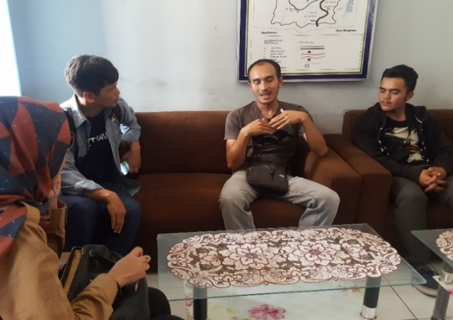

Figure 2
PPM Team and Partners when conducting FGD activities and Social Mapping for Coffee Farmer Business Development at Warnasari
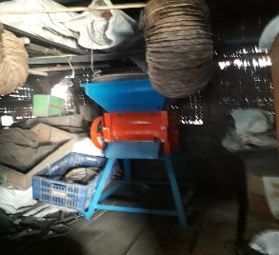
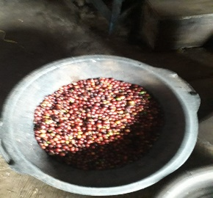

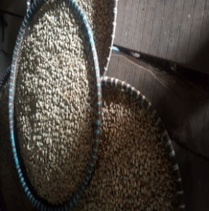
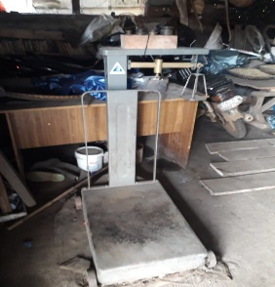

Figure 3
Condition of coffee processing warehouse in Hamlet 1
Desa Warnasari Pangalengan

The next activity was a visit to a coffee processing warehouse in Hamlet 1 of Warnasari Village and a privately owned coffee factory that invested in Pangalengan. The warehouse location looks as it is without adequate facilities. From observations, the facilities in the warehouse are only in the form of paring machines, scales, and open fields which also join the posyandu activities. The following is the condition of the coffee processing warehouse owned by Warnasari Village.

It is in this coffee warehouse that coffee farmers collect their harvests, weigh and then peel and then dry improperly through a natural drying process for several days using a large, empty container. After the coffee beans are dry, they are then sold to coffee dealers or collectors who are indeed purchased in the form of beans without a roaster. This is where the process of processing coffee Warnasari village ends, due to inadequate facilities and without the help of other venture capital.
The next activity is to visit a privately owned coffee processing factory in the nearest village, Desa Pulosari. This visit was deliberately carried out to conduct a comparative study to a place that already has more complete coffee processing operational standards. According to the results of interviews with partners, this factory is owned by a foreign party who deliberately invests in that location because Pangalengan coffee is known to have quite good potential and is already global, as is the existence of Kampung Kopi as a pilot located in Margamulya Village. The villagers made coffee plants a major asset in their lives. Especially after the guidance, cooperation and assistance from the Government of West Java Province in the form of product knowledge and coffee quality, in the end the Margamulya Pangalengan Village was designated as the Coffee Village. Thus it is not surprising that many entrepreneurs look at several villages in Pangalengan to be the location of a coffee business factory. But unlike in Warnasari Village, coffee farmers really still need intensive guidance from various parties, both from academia, government and other private sectors.
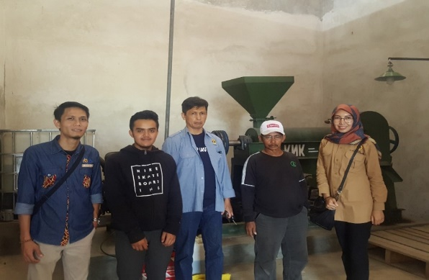
Figure 4
The PPM team and Partners visited a privately owned coffee factory in Pulosari Village

Social Mapping and FGD activities for the development of coffee farmers as a whole are still not effective in meeting the target, this is due to constraints of time and opportunity problems. Further efforts are needed by focusing more on the mental side of the coffee farmers so that they prioritize the process rather than the results, meaning that it needs to be further facilitated and assistance that stimulates their will and ability. Because basically coffee farmers in Warnasari have other agricultural commodities processed, such as potatoes, tomatoes, and other vegetables, so coffee is not a top priority in their business. This can be seen from the lack of enthusiasm of local residents to participate in this activity, as evidenced by the number of participants who attended only less than 10 people,
However, based on the results of in-depth interviews and evaluations of the implementation of Social Mapping and FGD activities from partners and Head of Hamlet 1 of Warnasari Village, community service activities basically gave good results although they still need further study, here are a few points that show the results ( output) of this group's community service:

- The addition of knowledge and understanding of partners, from the initial lack of enthusiasm in developing business, after being given an understanding of entrepreneurship, partners began to be interested to focus more on processing coffee businesses, at least there was a desire to develop business partners or work with coffee entrepreneurs in the place the other.
- Changing the mindset to be able to innovate from agricultural products, whatever the commodity, if the partner focuses on one commodity business, then that is where the results will be more optimal, meaning that the business will depend on the process; because indeed all this time partners have many variants of commodities and then only carry out routines as they are with limited capital, so it does not occur to innovate their agricultural products.
Through PPM activities or community service, the team provides several directions related to innovations that need to be done by partners or coffee farmers: (1) need to deepen about product knowledge (quality coffee), creativity of processed coffee, not just enough to be ground coffee results roasting or concocting a barista, but can innovate in the form of caramel candy in collaboration with dairy milk entrepreneurs, crackers, cakes or cakes, or other forms of food that are currently in demand by the general public. This of course requires further deepening and collaboration with food engineers. (2) relating to production problems, the need for additional facilities in the form of a coffee grinder by making a proposal for assistance to the local district government;

D. Conclusion
Community service activities in the Warnasari Village, Pangalengan District, Bandung Regency went fairly smoothly. The smooth running of the event was due to the good cooperation of the Village Heads, Hamlet Heads and Apparatuses, as well as local residents, especially partners / coffee farmers who participated in community service activities. Therefore, the conclusions that can be drawn from this activity are:
- Through Social Mapping and FGD activities on coffee business development, partners' knowledge about entrepreneurship has increased.
- By observing the global development of Pangalengan coffee (West Java), partners began to realize the importance of making additional efforts to focus on producing processed coffee as a potential asset and making it a top priority compared to other agricultural commodities they worked on.
After carrying out community service activities, we are able to provide input and suggestions, as follows:
- A further service and assistance program is needed related to the development of the coffee farmers' business in the Warnasari Village, Pangalengan District, Bandung Regency in the next period.
- Partnerships are needed with various institutions and other coffee business partners so that Warnasari coffee farmers can be more confident in developing the coffee business.
The need for attention and assistance in the form of facilities from the local government that can stimulate the entrepreneurial spirit of Warnasari Pangalengan coffee farmers, thereby synergizing with local economic empowerment in line with the Bandung Regency government program.

REFERENCES

Directorate of Research and Community Service, Directorate General of Research and Technology Strengthening Ministry of Research, Technology and Higher Education. Guidelines for Implementing Research and Community Service in Higher Education. XII Edition. Year2018.
http://www.warnasari.desa.id/first
https://kecamatanpangalengan.bandungkab.go.id/

