CLASS ACTION RESEARCH (CAR) TRAINING FOR TEACHERS IN SDN GAYUNGAN II SURABAYA

Danang Prastyo¹, Rarasaning Satianingsih², Ida Sulistyawati ³, Arif Mahya Fanny⁴
^{1,2,3,4}Universitas PGRI Adi Buana, Surabaya, Indonesia
¹danang@unipasby.ac.id, ²rarasaning.setyaningsih@gmail.com, ³ida@unipasby.ac.id, ⁴arifpgsd@unipasby.ac.id

ABSTRACT

Professional teachers can be seen from the ability of teachers to produce quality Classroom Action Research (CAR). If seen not all teachers are able to produce research in accordance with CAR standards. Through Community Service Program, Unipa Surabaya PGSD Study Program with the theme of Classroom Action Research Writing (CAR) for Elementary School Teachers in Gayungan II Elementary School in Surabaya is expected to help teachers in producing quality CAR. From the results of the training that has been carried out, it seems that the enthusiasm of the SDN Gayungan 2 Surabaya teacher in following the CAR was very good. The majority of participants felt they needed to get CAR training. Participants feel the benefits after receiving CAR training.

Keyword: Training, CAR, Elementary School Teacher

- Introduction
At this present the quality improvement and quality of teacher education continues to be improved. Various efforts have been made by the government and schools in improving the quality of teachers. One of the school's efforts to improve the quality of teachers is by upgrading teachers in Classroom Action Research (CAR). Miaz (2014) said, as a teacher educator is required to be able to do CAR. Sumini (2015) said that CAR needs to be done by teachers in order to overcome problems in learning. At present it is still found teachers have not done CAR in their schools, so learning problems that exist in the classroom cannot be solved (Slameto, 2015).
If we seen further, the duties and responsibilities of teachers in overseeing the success of education are quite large, this can be seen from the four competencies that must be mastered. These four competencies are pedagogic, professional, social and personality. Good and ideal teachers are teachers who have four core competencies, namely pedagogic, professional, social and personality (Sutarmanto, 2015; Dudung, 2018; Hendri, 2010). Whereas from these four competencies, CAR is included in professional competence. Mastery of CAR is very important in completing four competencies, considering the ability of teachers to make CAR in schools needs to be improved Francisco (2013).
As a Primary School Teacher Education Program (PGSD), PGSD Study Program is obliged to improve the quality and quality of education of elementary school teachers in East Java. For this reason, through the Community Service Program (PKM), PGSD Unipa Surabaya is assisting CAR writing to teachers at the Gayungan II Elementary School in Surabaya. The choice of the theme 'Classroom Action Research Writing (CAR) for Elementary School Teachers at Gayungan II Elementary School Surabaya' was chosen because there were some teachers who were confused in producing a good CAR. From some of the results of observations and interviews in school there are teachers who have difficulty in preparing proposals, conducting cycles or stages of CAR and making a final CAR report. However, if it is judged that CAR will have a positive impact on teachers and schools going forward. Slameto (2015) states that a good CAR will have a large impact in improving and improving the quality and quality of education in schools. CAR will provide a great opportunity for teachers to be more confident in teaching and learning (Khasinah, 2013; Arikunto, 2010). Widayati (2014) said, CAR will affect the quality of schools in general. In addition, the implementation of CAR will have an impact on improving the quality and quality of national education (Mediatati, 2016). Seeing the impact of CAR can provide benefits for teachers, schools, then PGSD Unipa Surabaya conducts CAR training in the Gayungan Surabaya Elementary School from 7-21 December 2019.

- Method of Implementation
This Community Service Program was carried out at Gayungan II Public Elementary School Surabaya, attended by 30 teachers. CAR is conducted in person. For Community Service Program material, it is divided into several materials, namely CAR principles, CAR procedures, and CAR implementation and CAR report writing material. Each level of participant material delivery will be measured and given a questionnaire related to participant responses during the training. For the Community Service Program stage, it can be seen in the following figure.
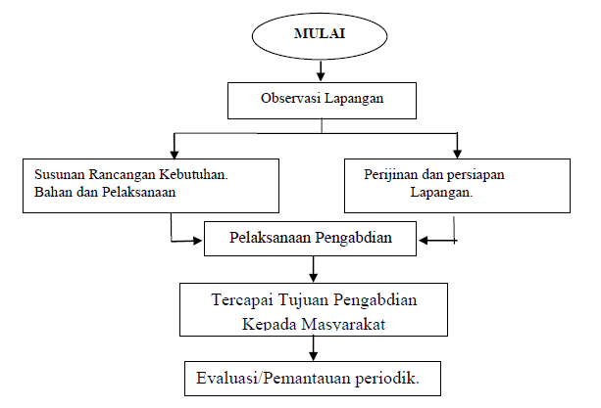
Picture 1. Community Service Program stage
From the picture above, it can be explained that the implementation of Community Service Program starts from field observations, drafting needs, taking care of permits, conducting Community Service Program and evaluating the success of Community Service Program training.

- Result and Discussion
The target of the training participants is 30 teachers at SDN Gayungan 2 Surabaya. In the implementation only 22 teachers participated. Many teachers are absent because there are activities outside the school. From 73% of the total number of participants attending the training it can be concluded that the level of teacher attendance in the training is quite good.
For the number of participants who attended the training were 22 teachers. Teacher participants were absent because many teachers were assigned to schools to participate in activities outside of school. Of the 22 participants who attended, they attended CAR training because they felt the need and as a need to increase their rank.
For material that has been delivered by the speaker has been planned carefully according to the situation and conditions on the field. The material arranged according to the time and level of understanding of teachers in understanding Community Service Program. As for the achievement of material that has been planned and implemented by the speaker can be concluded in either category or 80 percent.
For the ability of trainees during the training in either category or 80 percent. The ability of these participants can be seen from how to compile a title, how to make a problem statement, research objectives, make a learning plan, conduct learning in a cycle, improve or evaluate and make conclusions and compile a CAR report.
The results of the questionnaire satisfaction showed that 67 percent of participants were satisfied and 33 percent of participants felt very satisfied. For an explanation, see the following picture.
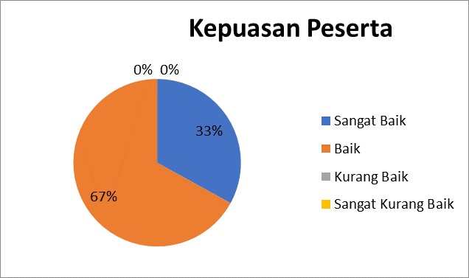
Picture 2. Participant Satisfaction in participating in the Training

From the results of the questionnaire suitability of the needs of participants who have been given shows that 70 percent of participants felt needed, 20 percent of participants felt very need and 10 percent of participants felt less needed. For an explanation, see the following picture.

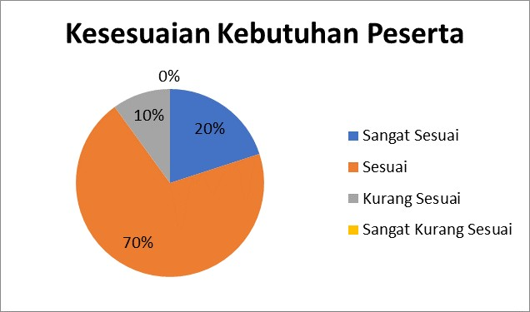
Picture 3. Suitability of Participant Needs
From the results of the questionnaire understanding the participants had given showed that 70 percent of participants felt understood, 17 percent of participants felt very understood and 13 percent of participants felt they did not understand. For an explanation, see the following picture.

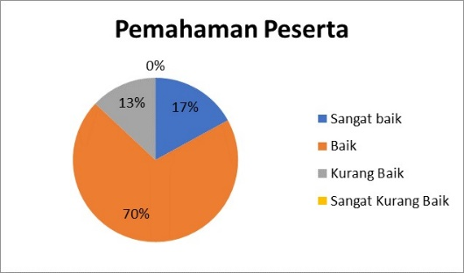
Picture 4. Participants Understanding of Materials
From the results of the questionnaire the meaningfulness of the activities given showed that 530 percent of participants felt meaningful, 37 percent of participants felt very meaningful, 7 percent of participants felt less meaningful and 3 percent of participants felt meaningless. For an explanation, see the following picture.

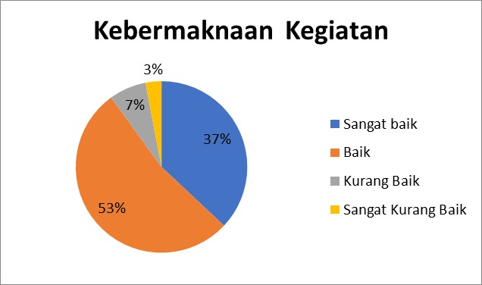
Picture 5. Significance of activities

From the results of the mentoring that has been done for one month, it can be seen that there is an increase in the understanding of teachers in preparing and making a CAR report. During the training process the teacher's enthusiasm in participating in the training was very good, as seen from the many participants who asked and answered the questions of the speakers. In addition there is also full support from the principal of SDN Gayungan 2 Surabaya in the success of the Community Service Program training until the implementation is over. The obstacles encountered during the training were not so great as the lack of precise time in starting the training. Sometimes the training is not timely because there are some teachers who still solve school administration problems. In general, Community Service Program in Gayungan 2 Public Elementary School's Surabaya compilation and writing training can be said to be successful.

- Conclusion
From the results of the analysis of the data that has been done it can be concluded that the enthusiasm of the SDN Gayungan 2 Surabaya teachers in following the CAR was very good. The majority of participants felt they needed to get Community Service Program training. Participants feel the benefits after receiving Community Service Program training.

REFERENCES

Arikunto, S. (2010). Penelitian Tindakan Kelas. JURNAL UNY , JURNAL PENDIDIKAN AKUNTANSI INDONESIA Vol. VI No. 1 – Tahun 2008.
Dudung, A. (2018). KOMPETENSI PROFESIONAL GURU. JKKP (Jurnal Kesejahteraan Keluarga Dan Pendidikan). https://doi.org/10.21009/jkkp.051.02
Francisco, A. R. L. (2013). PENELITIAN TINDAKAN KELAS (CAR). Journal of Chemical Information and Modeling.
Hendri, E. (2010). Guru Berkualitas: Profesional dan Cerdas Emosi. Jurnal Saung Guru.
Khasinah, S. (2013). Classroom Action Research. Jurnal Pionir, Volume 1, Nomor 1,. https://doi.org/10.17977/um013v1i42017p156
Mediatati, N. (2016). UPAYA MENINGKATKAN KOMPETENSI GURU DALAM MENYUSUN PROPOSAL PENELITIAN TINDAKAN KELAS MELALUI MODEL PELATIHAN PARTISIPATIF DENGAN PENDAMPINGAN INTENSIF. Kelola: Jurnal Manajemen Pendidikan. https://doi.org/10.24246/j.jk.2016.v3.i1.p148-163
Miaz, Y. (2014). Penelitian tindakan kelas bagi guru dan dosen. In Penelitian tindakan kelas bagi guru dan dosen.
Slameto, S. (2015). IMPLEMENTASI PENELITIAN TINDAKAN KELAS. Scholaria : Jurnal Pendidikan Dan Kebudayaan. https://doi.org/10.24246/j.scholaria.2015.v5.i3.p47-58
Sumini. (2015). Penelitian Tindakan Kelas dan Pengembangan Profesi Guru. Jurnal Pendidikan.
Sutarmanto. (2015). Kompetensi Dan Profesionalisme Guru. Jurnal Visi Ilmu Pendiidkan.
Widayati, A. (2014). PENELITIAN TINDAKAN KELAS. Jurnal Pendidikan Akuntansi Indonesia. https://doi.org/10.21831/jpai.v6i1.1793

